CIT4224
Internet & Web Publishing

Trimester 2, Session 2024 / 2025

Project Title:

BY

No. |  | Student ID |  | Student Name

Table of Contents
TABLE OF CONTENTS 1
TASK DISTRIBUTION FORM 2
PROJECT EVALUATION FORM 3

PART 1: INTRODUCTION 4

PART 2: OBJECTIVE OF THE WEBSITE 5

PART 3: TARGET USER 6

PART 4: SCREENSHOTS OF THE WEBPAGE 7

REFERENCES 8
APPENDIX (Meeting Minutes) 9

TASK DISTRIBUTION FORM

No. | Student ID | Student Name | Tasks Completed | Signature
 |  |  | ie. Homepage, JavaScript, drop-down menu

CIT4224 Internet & Web Publishing
PROJECT EVALUATION FORM

STUDENT ID | STUDENT NAME | Peer Evaluation Total Marks (20M)  (For Evaluator Use) | Project  (For Evaluator Use)  (40M)

1 | Very Poor | 2 | Poor | 3 | Average | 4 | Good | 5 | Excellent
WEBSITE:
Criteria | Marks | Comments/ Remarks
- Content (User/Customer)
- Content relevance, appropriateness, organization and presentation
- Content (Administrator):
- Content relevance, appropriateness, organization and presentation
- Graphics & CSS
- Hyperlinks
- Form
- Multimedia elements
- Extra features (responsive element, javascript)
- Overall design
Total (40)

REPORT:

Criteria | Marks | Comments/ Remarks
- Checklist & Evaluation Form | /2
- Task distribution | /2
- Objective/Purpose | /2
- Target User | /2
- Screenshot of website | /10
- Cover page completed | /1
- Header, Page number and title numbering are included | /1
Total (20)

PRESENTATION:

Criteria | Marks | Comments/ Remarks
- Clarity of speaking | /3
- Understanding of the website | /4
- Presenter’s appearance (formality, professionalism) | /3
Total (10)

PART 1: INTRODUCTION

This section describes the topic selection and explain/list the web pages that you have developed.

PART 2: OBJECTIVE/PURPOSE OF THE WEBSITE

PART 3: SCREENSHOTS OF WEBPAGE

This section includes screenshots for each web page(including user and administrator).

Example screenshot:
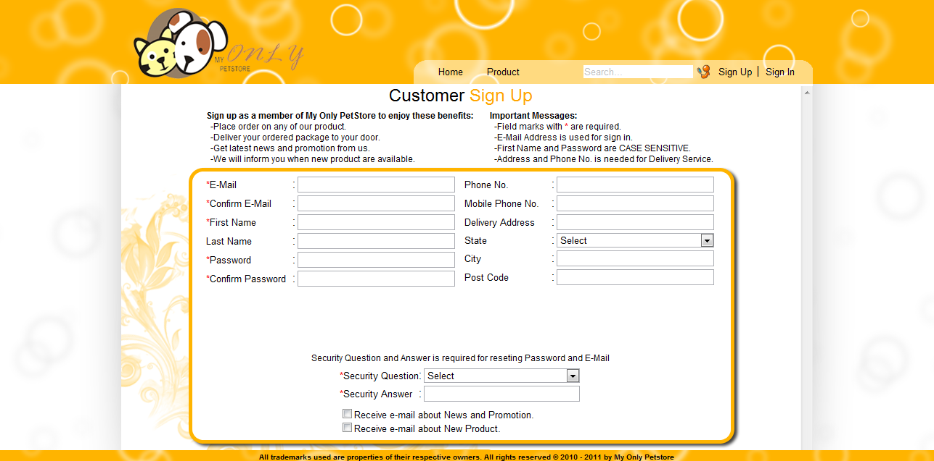

Figure 1. Customer Sign up Page

REFERENCES/BIBLIOGRAPHY
List of URL addresses or reference books

APPENDIX

Meeting No. | 1
Project Title | Cookies Ordering System
Date | 21 August 2019
Time | 2.00 p.m. – 4.15 p.m.
Venue | MBMR3023

ATTENDANCE
Present | Absent
- Ali Hassan  - Raj Kumar | - Jackson Lee

NO | ITEM | INFO/ACTION
1 | - Discuss on the dates and time for each meeting to be held.  - Decision was made that every Thursday from 8:00 p.m. to 11:00 p.m will be the meeting time. | All
2 | - Each Group member have to find 2 websites related to the project title.  - Ali have to do research on how to create a CSS based web page layout.  - Jackson have to …. | All  Ali  Jackson

The meeting adjourned at 4:15 p.m.
Prepared by:

Raj Kumar

